# [NoLytics] Site Plan

## [Melanie Maldonado]

## WDD 130

## Overview

### Purpose

### The purpose of my website is to be fun and lighthearted. At first, it looks like a serious site offering real advice, but as you read, you’ll realize it’s all simple, sarcastic, and intentionally silly. It’s designed to parody overly serious information sites playfully for the audience. We also make sure to deliver the kind of advice that makes you say, “Wait… what?”

### Audience

My website is intended for people of all different ages

## Branding

### Website Logo

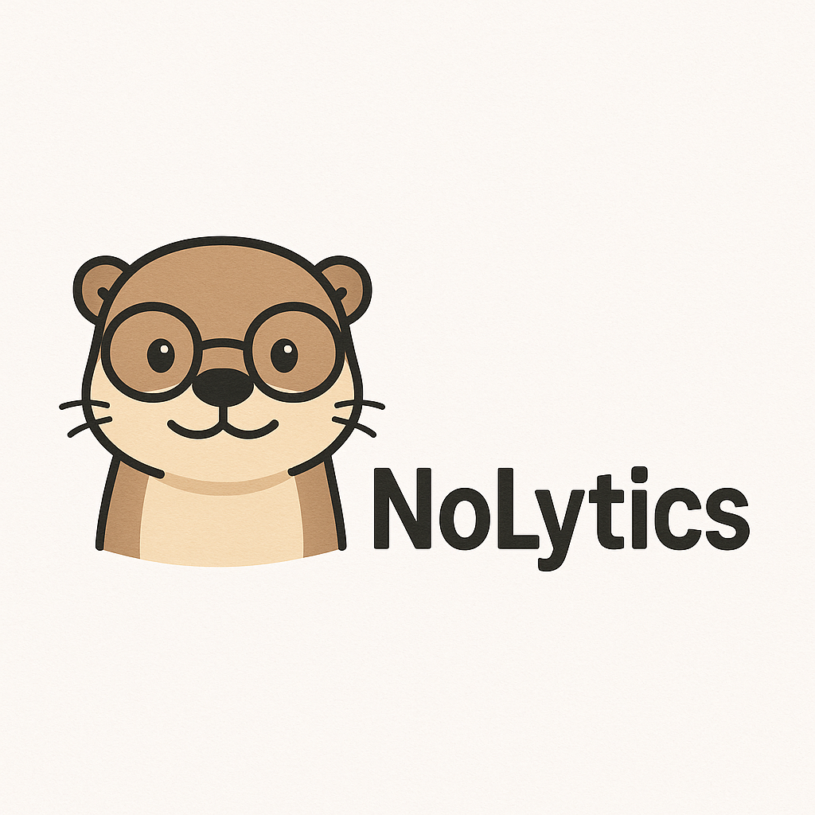

## Style Guide

### Color Palette

|  |  |  |  |
| --- | --- | --- | --- |
| **Primary** | **Secondary** | **Accent 1** | **Accent 2** |
| #8D6E63 | #FFF3E0 | #37474F | #B0B0B0 |

### Typography

#### Heading Font: [Cursive, Fantasy]

#### Paragraph Font: [Sans-serif, Monospace]

### Navigation

Home Page2 Page3

**Content**

Home page

Welcome to NoLytics!

**Description:**  
Welcome to NoLytics, the world’s most confidently wrong source of information. At first glance, we look legit—but stick around and you’ll realize it’s all sarcasm, nonsense, and adorable otters in glasses. Because why be helpful when you can be hilarious?

**Our purpose:**

Page 2/ The Data Center

Title: Life-Changing Tips (That Probably Won’t Help)

**Description:**

At Nolytics, we deliver advice you didn’t ask for and probably shouldn’t follow. Our research is as solid as a Google search done at 3 AM. Browse our top-tier recommendations- from productivity naps to passive-aggressive communication

**Advice:**

* **Feeling sleepy:** If you're feeling sleepy, take a 10-hour “power nap.” Set an alarm… but ignore it. If your body wants rest, who are you to argue with science?
* **Feeling Overwhelmed:** Say “I’ve got this” out loud. Then proceed to ignore the situation entirely. Confidence solves everything
* **Want to Look Smart:** Just say “that’s interesting” in response to anything. Bonus points if you nod slowly while doing it
* **Don’t Know What To Say:** Just say “That’s wild”. Works for stories, complaints, and random life updates
* **Running Late?** Say, “I’m on my way!” even if you’re still in bed. Technically, you are- eventually
* **Hungry but Don’t Want To Cook?** Open the fridge, close it, and open it again 5 minutes later. This counts as “meal planning.”
* **Want to eat healthy?** Eat a salad. Then cancel it with a brownie. Balance is key
* **Bored out of your mind?** Scroll endlessly through things you don't care about. You'll feel worse, but at least it's something to do.

Page 3/ Contact

**Description:**

NoLytics was founded by a team of overthinkers, underachievers, and one extremely smart otter. Our mission? To sound smart while saying nothing. If you’re still reading, congratulations—you’re one of us

**Contact Section:**

Have questions? Great! So do we

Email us at [hello@nolytics.com](mailto:hello@nolytics.com) or yell into the unknown- we’ll probably hear it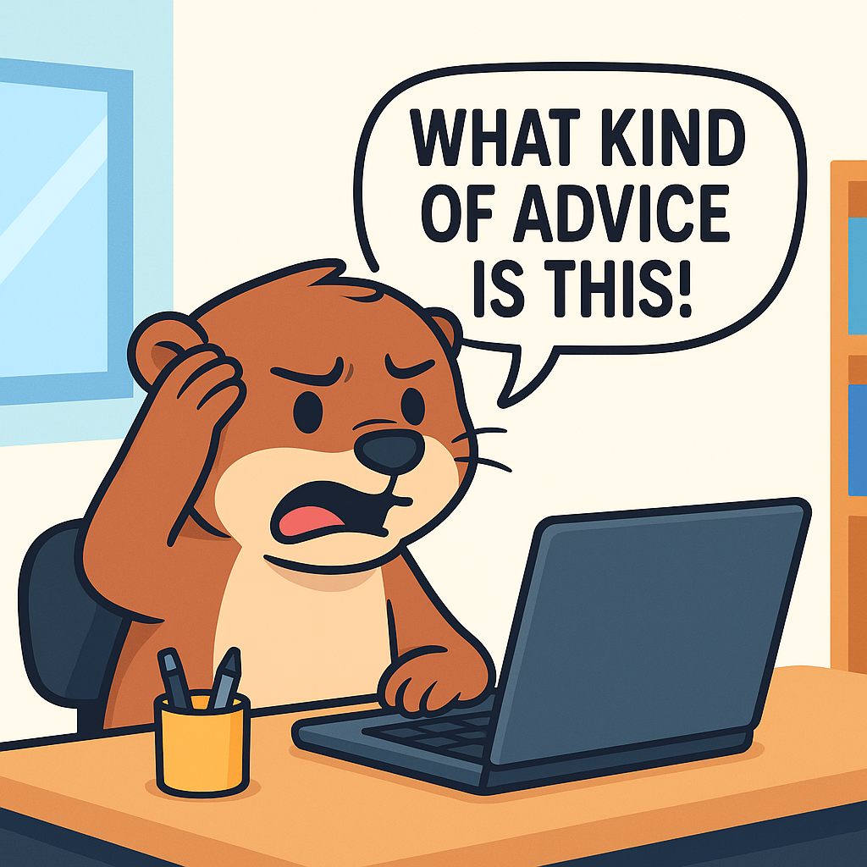

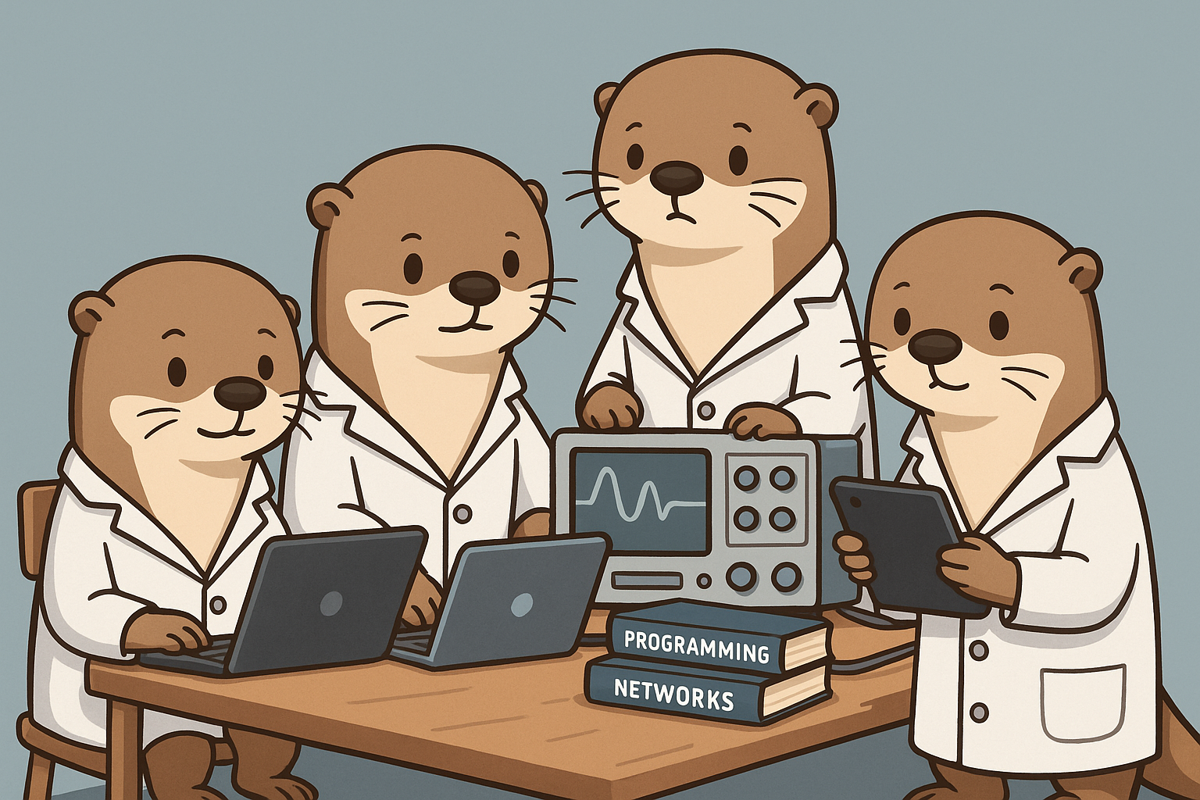





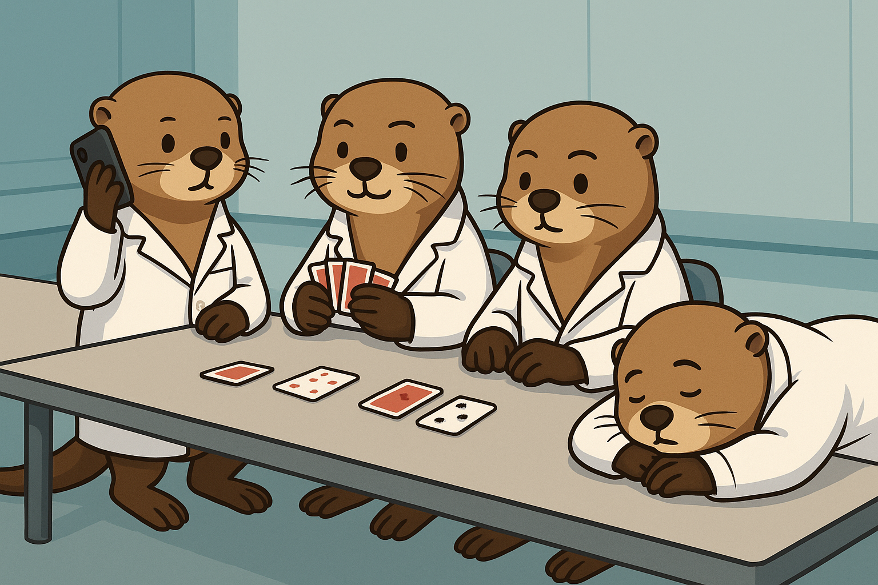

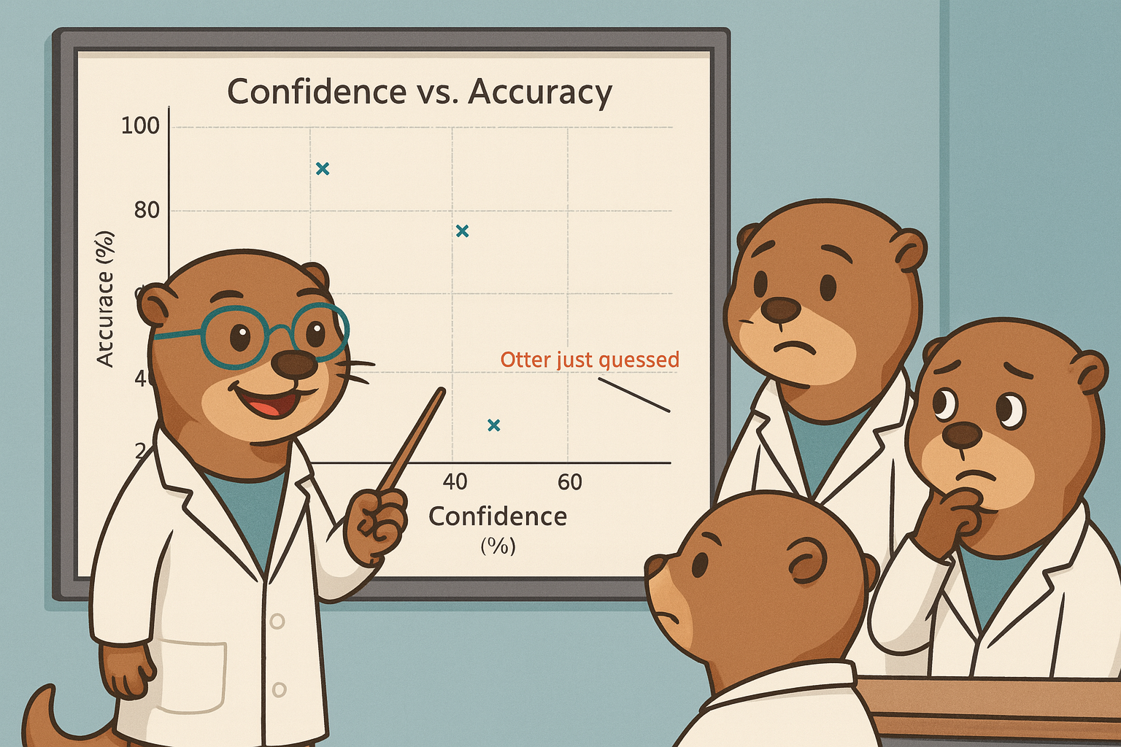

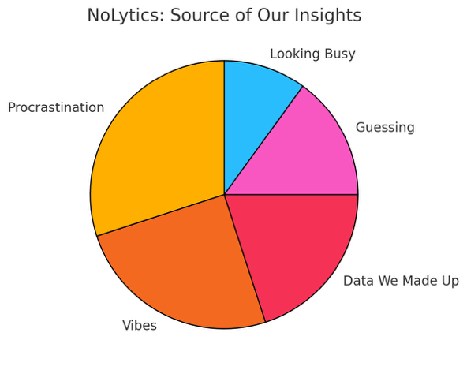

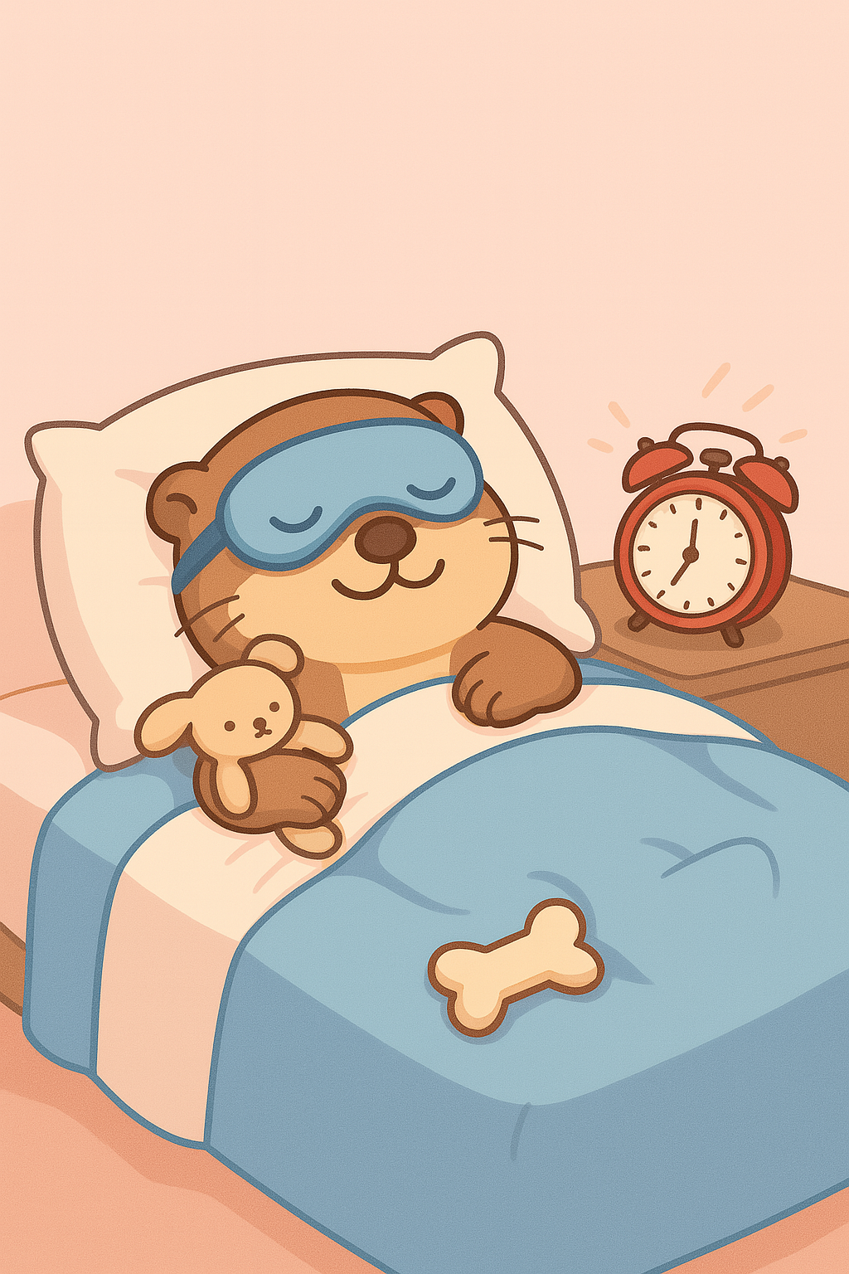

**Wireframes**

### Home



Page 2/ The Data Center



Page 3/ Contact  
